

*shell programming lab*

aSsignment -3

**SUBMITTED BY: SUBMITTED TO:**

**AYUSH KUMAR JHA Dr. Dhiviya Rose**

**SAP ID - 500086400**

**Enrollment no - R200220083**

**B.C.A -I.O.T.**

Activity 1:

a) b)

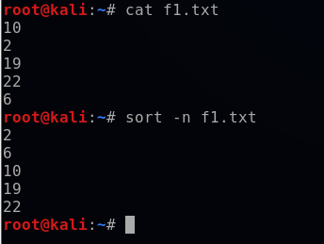

C)

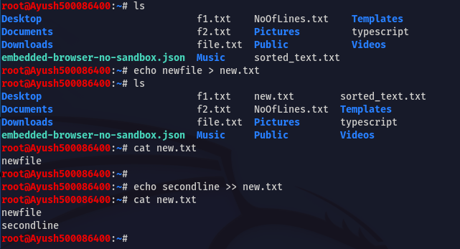

**tee command**

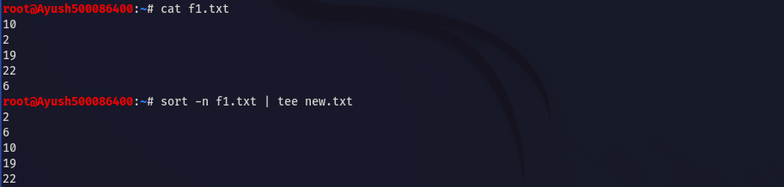

Activity 2:

a) b)

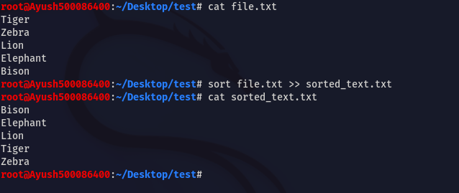

c)

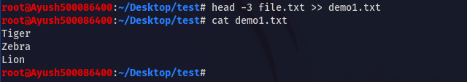

d)

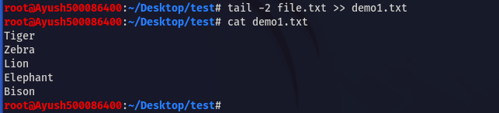

e)

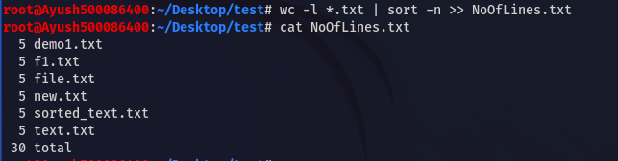

Activity 3:

A) B)

